**48. Use With**

--- **note** - you will learn how to use the with conditional block.

--- **note** – I will access the list of values which are present in values.yml from deployment.yml.

--- tree

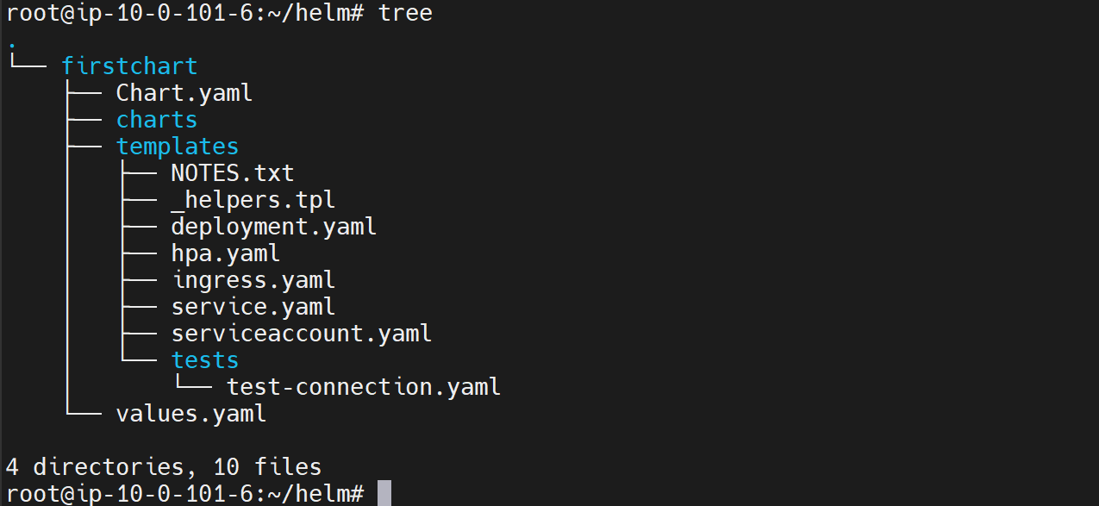

--- cat values.yml

# Default values for firstchart.

# This is a YAML-formatted file.

# Declare variables to be passed into your templates.

my:

  flag: true

  values:

    - usq

    - india

    - mexico

    - brazil

    - uk

replicaCount: 1

image:

  repository: nginx

  pullPolicy: IfNotPresent

  # Overrides the image tag whose default is the chart appVersion.

  tag: ""

--- note - --- this is the list of the values. With is empty then nothing will there in the output if it has value then it will be part of output.

--- cat deployment.yml

apiVersion: apps/v1

kind: Deployment

 {{- if .Values.my.flag}}

 {{"output of if" | nindent 2}}

 {{- else}}

 {{"output of else" | nindent 2}}

 {{- end}}

**{{- with .Values.my.values}}**

**{{- toYaml . | nindent 2}}**

**{{- end}}**

spec:

  {{- if not .Values.autoscaling.enabled }}

  replicas: {{ .Values.replicaCount }}

  {{- end }}

  selector:

    matchLabels:

      {{- include "firstchart.selectorLabels" . | nindent 6 }}

--- **$.** – If you want to use dot values and navigate within the if block, you should use a special symbol called dollar.

--- **. (dot)** -Dot again points to the route, but if you simply use Dot. Dot points to the current element that is being checked.

--- **toYaml** – convert output into yml format.

--- **note** – you can also use else block with with block.

**# Check the template of firstchart**

--- helm template firstchart

